Inya.ai Buildathon – Concept Note

TEAM DETAILS
1.Team Name – MediMinds
Members:
Ramya A – Chatbot developer ,UX Flow
Sudha SP – Form & Social Media Handler
Contact Email : 231801135@rajalakshmi.edu.in

2.Problem Statement
Booking Appointments , rescheduling and managing medical records remains a time consuming process for patients ,especially in non-digital clinics. Patients often struggle with long waiting times, lack of confirmations and repetitive manual processes.
Why it matters?
Makes Patient Satisfaction and clinic productivity
Common in smaller healthcare startups without automation
Who faces this?
* Walk-in / Out patients
* Receptionists managing records manually
* Clinics without tech support

3.Proposed AI Agent
- Agent Name : MediMate
- Brief Description:
MediMate chat is a conversational AI assistant that helps patient book, reschedule or cancel appointments ,upload medical documents and get instant confirmations through Google Forms ands email notifications.
- Key Differentiator:
Unlike generic bots,MediMate integrates directly with Google Forms to send real-time confirmation emails and requires no code setup – perfect for small clinics with minimal tech resources.

4.Industry & Use Case
- Target Industry: Healthcare – OutPatient Clinics and Hospitals
- Expect Business Impact
*Reduction in patient waiting time
*Emergency patients can meet their doctors by prior appointments
*Instant email confirmations improve trust
*24/7 automated interactions for patients

5.Inya.ai Agent Link
https://app.inya.ai/agent/update?agentId=2f63d90a058e4878bc89173f7bd2809c

This article reviews nuclear power plants (NPPs), noting their high electricity output and low carbon emissions but high capital costs. It examines the NuScale Reactor’s design, safety, and role in seawater desalination. NPPs create jobs and affect the environment, including water, soil, air, and ecosystems. Efficient desalination methods like reverse os mosis and multi-effect distillation provide clean water.

The use of Artificial Intelligence (AI) in nuclear in-core instrumentation and control can enhance the safety and efficiency of nuclear power plants. AI analyzes real-time sensor data to detect anomalies and prevent accidents. It also optimizes reactor operations by learning from past performance to improve control strategies. Overall, AI can make nuclear plants safer, more efficient, and more reliable as technology advances.

Flow Diagram
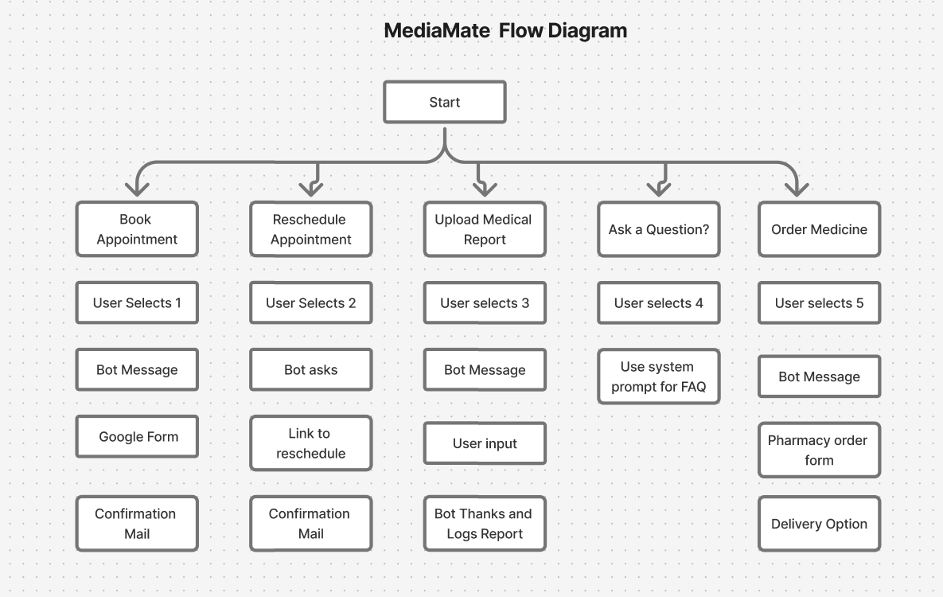

The use of Artificial Intelligence (AI) in nuclear in-core instrumentation and control can enhance the safety and efficiency of nuclear power plants. AI can analyze real-time sensor data to detect anomalies and prevent accidents before they occur. It can also optimize reactor operations by learning from past performance and improving control strategies. Overall, AI has the potential to make nuclear power plants safer, more efficient, and more reliable as technology advances.
Artificial Intelligence (AI) in nuclear in-core instrumentation improves plant safety and efficiency. It analyzes real-time sensor data to detect anomalies and prevent accidents. AI also optimizes reactor operations by learning from past performance to improve control strategies. Overall, AI enhances the reliability, efficiency, and safety of nuclear power plants.
Here’s a tightened version that should fit neatly into 4 lines in Word, font size 14:

Here’s a concise 3-line version suitable for Word, font size 14:

As Chinese nuclear plants move from RSEM to ASME standards, inspections now include nickel-based tubes and welds. This study uses time-of-flight diffraction (TOFD) to detect stress corrosion cracking and was verified through CIVA simulations and experiments. Results meet ASME requirements, with future work optimizing TOFD for complex reactor conditions.
Here’s a 4-line version suitable for Word, font size 14:

This paper proposes an enhanced fuel failure diagnosis method for pressurized water reactors, improving detection of failures, number of failed rods, and failure size. Other factors affecting diagnosis are also discussed. The method is verified using operational data from Chinese nuclear power plants. Results show it accurately identifies fuel failures and has broad applicability.
Here’s a tighter 4-line version suitable for Word, font size 14:

This paper presents a threat-driven modeling framework to enhance security in safety-critical nuclear software. It includes missing attributes like deadlock and liveness beyond traditional integrity and access control. System functionality is modeled with Petri nets, analyzing behavior and structure for threat mitigation. The approach is validated on 11 nuclear safety-critical systems, with one case study shown.
Here’s a concise 4-line version suitable for Word, font size 14:

This paper explores small-capacity nuclear power plants (SNPPs) with high-temperature gas-cooled reactors (HTGR) for electricity, heat, and hydrogen production. Mathematical models of gas and steam turbine units, and a steam methane reforming unit, were developed. Results show the integrated system increases fuel utilization from 47% to 78.1%. Combined production reduces the standardized electricity cost by $1.14/MWh compared to separate production.
Here’s a 4-line version suitable for Word, font size 14:

This study determines suitable locations and reactor types for nuclear power plants (NPPs) in Turkey using Analytic Network Process (ANP). A set of 3 main criteria and 20 sub-criteria was established, focusing on economic, social, and technical factors for site selection and technical factors for reactor choice. Giresun, Trabzon, Rize, and Artvin provinces in the Eastern Black Sea region were evaluated. The optimal combinations were determined as Giresun (PWR) > Rize (PWR) > Trabzon (BWR) > Artvin (BWR).
Here’s a 4-line version suitable for Word, font size 14:

Accurate prediction of power changes is vital for nuclear power plant safety and stability. This study proposes the ML-GRU-RS method, combining MAML, GRU, and random search optimization for long-term prediction of key plant parameters. The approach leverages MAML’s adaptability, GRU’s time-series processing, and random search efficiency for high-precision predictions. Results show it effectively forecasts parameter trends, enhancing operator ability and overall plant safety.

